Mitosis Things to Know
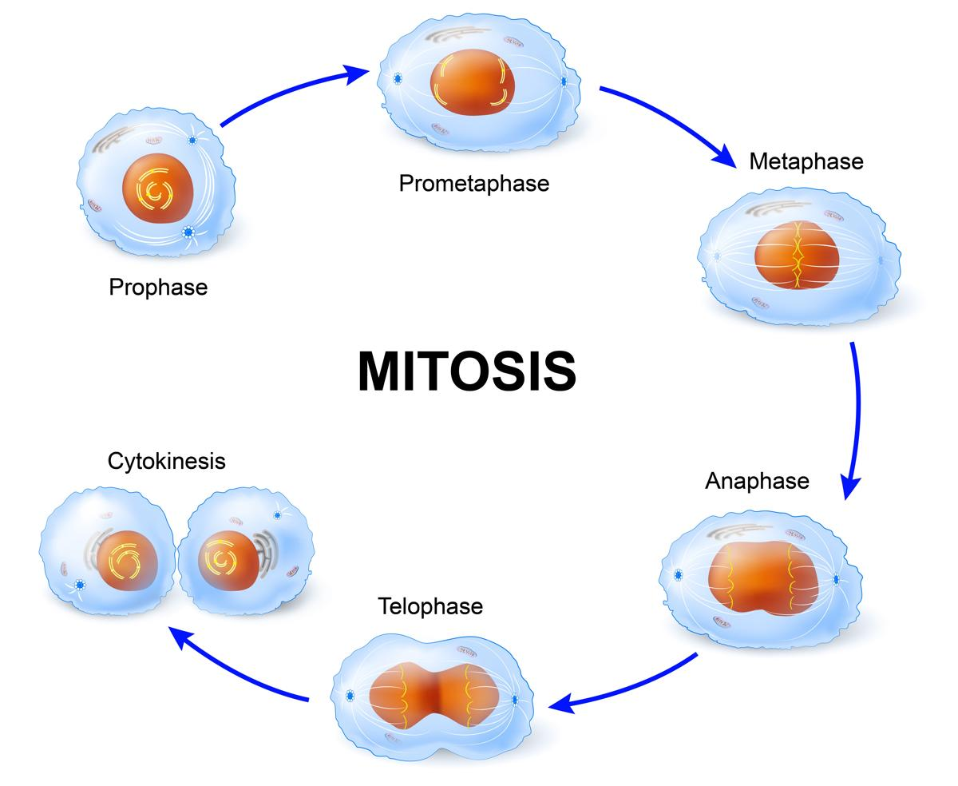
Name _________________________
Test Date is ____________________
30 Multiple Choice Questions

Vocabulary to know:
Anaphase  Centrioles  Centromere  Chromatids  Cytokinesis | Interphase  Metaphase  Prophase  Spindle Fibers  Telophase

Concepts to understand:
1. Understand what Interphase is and how long it is compared to Mitosis and Cytokinesis

2. How is Cytokinesis different in plants than in animals?

3. What is the sequence of the cell cycle?

4. What happens during:
a. Growth 1 (G1)
b. Synthesis (S)
c. Growth 2 (G2)
d. Mitosis (M)
e. Cytokinesis (C)
5. List the steps of Mitosis in order
6. What happens during:
a. Prophase

b. Metaphase

c. Anaphase

d. Telophase
7. How does the chromosome number compare before and after Mitosis and Cytokinesis?

8. What are the results of Mitosis?

9. How does increased volume effect how quickly a cell uses up food & nutrients and produces waste?

10. What does the spindle do during Mitosis?

