Cell Growth and Reproduction REVIEW PAGE
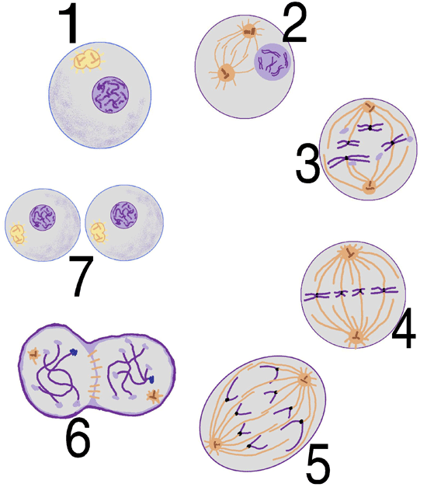
Be able to explain what’s happening at
each step shown here.

Steps 3-6 are PMAT phases of mitosis… what’s
going on there and what are those other numbers
showing?

Number 1_____________________________________________
_________________________________________________________
_________________________________________________________
Number 2 _____________________________________________
_________________________________________________________
_________________________________________________________
Number 3 _____________________________________________
_________________________________________________________
_________________________________________________________
Number 4 _____________________________________________
_________________________________________________________
_________________________________________________________
Number 5 ____________________________________________________________________________________
________________________________________________________________________________________________
Number 6 ____________________________________________________________________________________
________________________________________________________________________________________________
Number 7 ____________________________________________________________________________________
________________________________________________________________________________________________

8. What is the purpose of mitosis? How do the new daughter cells compare to the original?________________________________________________________________________________________________________________________________________________________________________________________

9. If a cell with 20 chromosomes goes through mitosis, How many chromosomes will each daughter cell have? ___________________________

10. What develops during cytokinesis of a plant cell? ____________________________________

