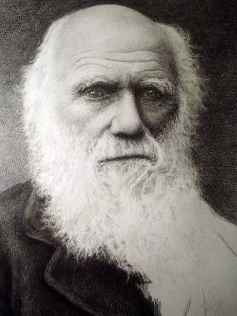
Name ___________________________
Test Date ___________ Period ___

Bio Ch15&16
Adaptations, Natural Selection, & Speciation
Things to Know

Vocabulary to know (must define for full bonus points)
Acquired Characteristics  Adaptation  Analogous Structures  Artificial Selection/Selective Breeding  Convergent Evolution  Directional selection  Disruptive selection  Divergent Evolution | Evolution  Gene pool  Genetic Drift  Genetic Equilibrium  Genotype  Geographic Isolation  Fitness  Homologous Structures  Inherited Characteristics | Mutation  Natural Selection  Phenotype  Population  Reproductive Isolation  Speciation  Stabilizing Selection  Temporal Isolation  Vestigial Structure
Concepts to Understand
Part I Natural Selection
- Darwin Background and Influences
- What did James Hutton and Charles Lyell add to Darwin’s understanding?

- Jean-Baptiste Lamarck had some right ideas and some wrong. List two of each.

- What is the difference between acquired and inherited characteristics?

- Who was Thomas Malthus and how did his theories relate to Darwin’s?

- Where did Darwin go and when?

- What was the name of his ship?

- What was the title of Darwin’s book and when was it published?

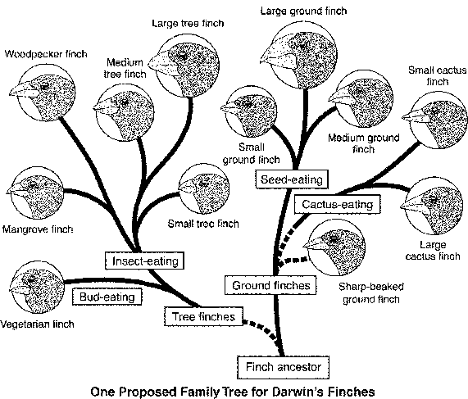
- What did Alfred Russell Wallace have to do with Darwin publishing his book?
B. Darwin’s Finches
- Describe how Natural Selection helps species adapt to their environment.

- Compare Darwin’s finches to those on mainland South America.

- What structural adaptation did see among finches in the different islands?

- What did Darwin mean by “Survival of the Fittest”?

- What does Darwin’s theory say about the number of offspring produced?

- What does Darwin say about how quickly evolution takes place?

- Describe the process Rosemary and Peter Grant observed among the finches.

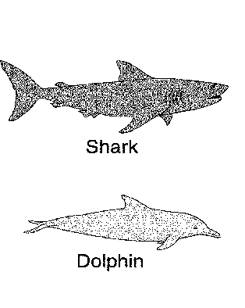
- Anatomical Evidence for Evolution
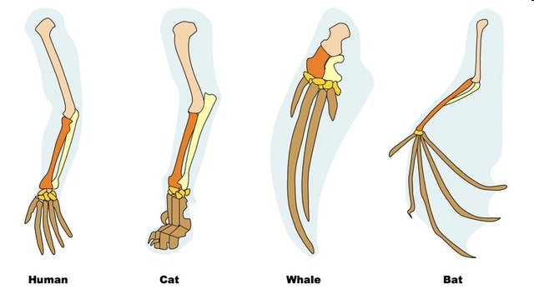
- Describe the difference between homologous and analogous structures.

- Which pictures to the left shows which? Label them.
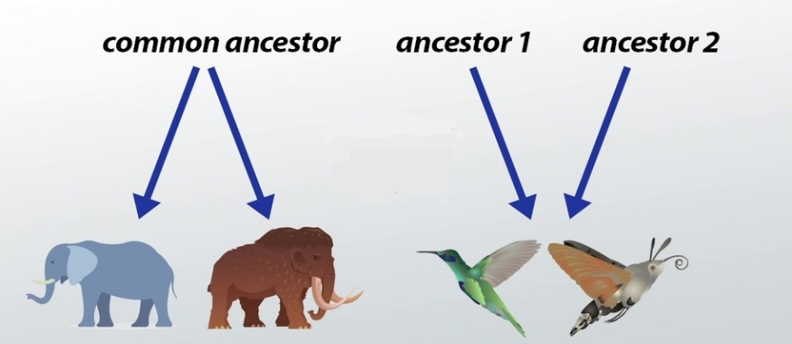
- Also label which show convergent and divergent evolution.

- Describe vestigial structures.
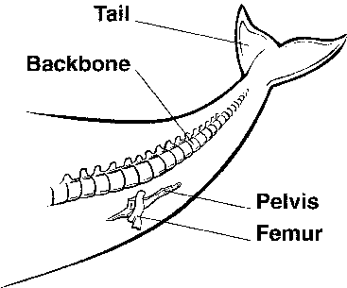

- How does is this whale an example of a vestigial structure?

- Give an example of a vestigial structure in humans.

7.How does embryology support evolution?
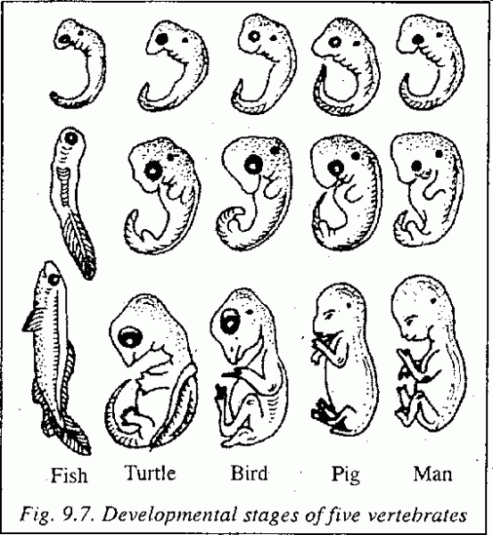
8.How does the study of fossils support evolution?

- Genetic Evidence for Evolution

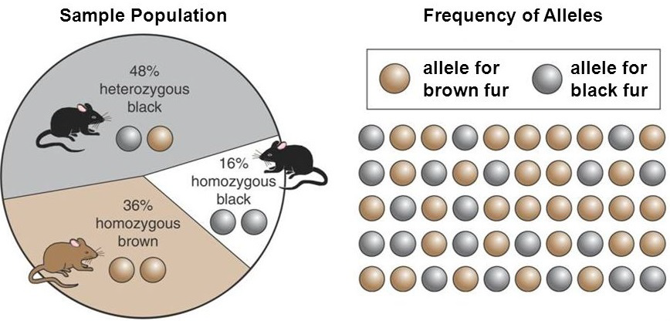
1. Define/Describe what is meant by gene pool.

2. Define a population.

3. What do we mean by the frequency of alleles?

4. What are the two main sources of genetic variation?

5. If you know how to shuffle cards to play a game, then what do you think is meant by genetic shuffling?

- Define Mutation
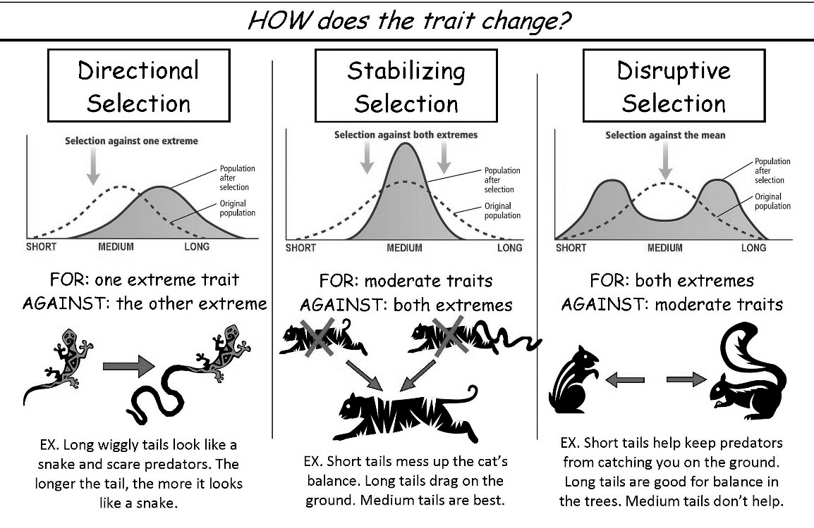
Part II Speciation
- Genetic Drift
      - What is meant by directional selection?

      - Define stabilizing selection.

      - Describe disruptive selection

      - If individuals at only one end of a bell curve of phenotype frequencies have high fitness, the result is which type of selection?

      - The many different forms of beak among a population of finches is probably a result of what type of selection?

      - If most human are average height which type of selections would that show?

7.Describe the Hardy-Weinberg Principle.

8. What is it called when allele frequencies don’t change, and remain constant?

- What 5 things must happen for the above to take place?

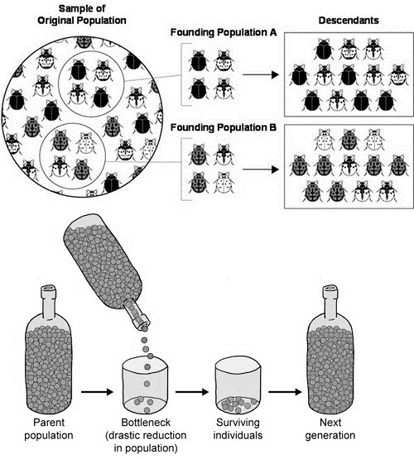
- Describe Genetic Drift, is it ordered or random?

- What size of populations are associated with genetic drift?

- Describe the founder effect shown to the left.

- What is the bottleneck effect?

- Reproductive Isolation
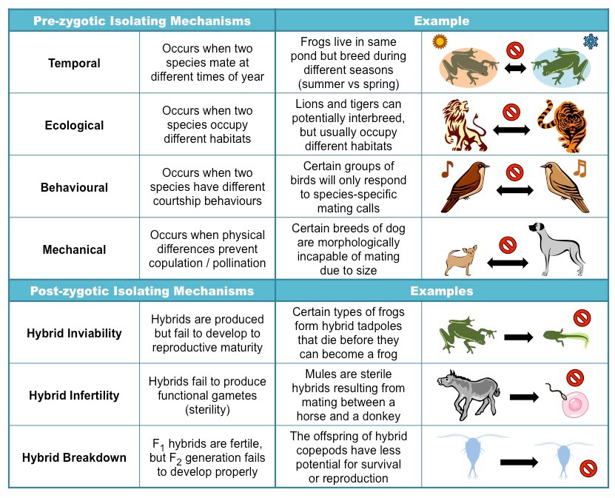
- What factor is necessary for the formation of a new species?

- How does geographic (aka ecological) isolation between two species cause increased differences in their gene pool?
- Which of the above may develop in a group of plants whose flowers open early in the morning and others that open late in afternoon?

