AMOEBA SISTERS: VIDEO RECAP | FOOD WEBS, ENERGY PYRAMIDS, AND AN INTRODUCTION TO BIODIVERSITY

Amoeba Sisters Video Recap: Food Chains, Food Webs, and an Introduction to Biodiversity
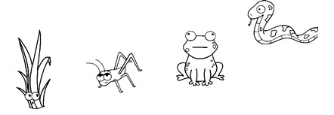
1. For the food chain on the right, please draw in three arrows to represent the correct direction of energy flow. Then use this food chain to answer the below questions.
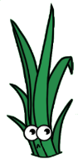  2. For the grass, please circle any of the below alphabetized words in this box that correctly describe this organism.  Note: You will have more than one word circled.  Autotroph  Producer  Decomposer  Secondary Consumer Heterotroph  Tertiary Consumer Primary Consumer | 3. For the frog, please circle any of the below alphabetized words in this box that correctly describe this organism.  Note: You will have more than one word circled.  Autotroph  Producer  Decomposer  Secondary Consumer Heterotroph  Tertiary Consumer Primary Consumer
- Please arrange the organisms from the food chain into an energy pyramid. After drawing your energy pyramid below with the labeled organisms inside, please label it with the following words: 1st trophic level, 2nd trophic level, 3rd trophic level, and 4th trophic level.  - If the grass in this example had 25,000 Kcal of energy, approximately how much would you expect of that energy to be stored in trophic level 4? ___________________Kcal | - Fungus is an organism not drawn in the above food chain although it has a very important role. Describe an important role of organisms such as fungi and bacteria:  _________________________________________________  _________________________________________________  _________________________________________________  _________________________________________________  _________________________________________________  - Circle any applicable words below that could correctly identify the organism above:  Autotroph Decomposer  Heterotroph Producer

AMOEBA SISTERS: VIDEO RECAP | FOOD WEBS, ENERGY PYRAMIDS, AND AN INTRODUCTION TO BIODIVERSITY

8. For the food web below, please draw in arrows to represent the correct direction of energy flow.
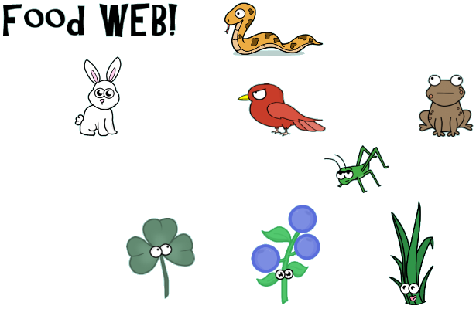
Please use the above food web to determine whether there is an increase, decrease, or no change for each organism type in the chart below based on the given scenario. When filling in the empty boxes, please explain why you determined an increase, decrease, or no change. Two boxes have been filled in for you!
Scenario | Frogs | Grasshoppers |  | Snakes | Producers
There are types of pathogenic fungi that can attack living amphibians (such as frogs). One of these types of fungi is known as the Chytrid fungus. For each of the following organisms in the table, describe how each organism population might be affected by a Chytrid fungus infestation. | Decreasing due to infestation of Chytrid fungus, which is harming frog population. | 9. | 10. |  | 11.
Grasshoppers can be extreme pests for farmers as they can damage crops. For each of the following organisms in the table, describe how each organism population might be affected by a significant grasshopper population increase such as a visiting locust swarm. | 12. | Increasing due to visiting locust swarm. | 13. |  | 14.
15. Which of the following contributes more to ecosystem sustainability: the food web on this page or the food chain on the other page? Explain your answer in terms of biodiversity.

